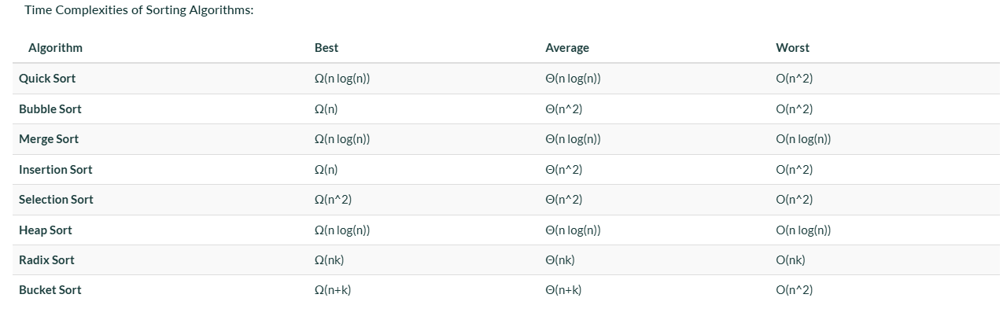

⭐ What Is the Fast Sorting Algorithm?
When people say fast sort, they usually mean one of these:

✅ 1. Quick Sort (FASTEST in practice)
This is the algorithm most people mean when they say fast sort.

🔹 Why is Quick Sort fast?
- Uses divide and conquer
- Splits array around a pivot
- Works very well in real-world data
- Used internally in many languages (like C’s qsort())

🔹 Time Complexity
Case | Complexity
Best | O(N log N)
Average | O(N log N)
Worst | O(N²) (rare when pivot chosen well)

🔹 Space: O(log N)

⭐ 2. Merge Sort (Fast and Stable)
Also extremely fast and guarantees O(N log N) always.

🔹 Why fast?
- Recursively splits array into halves
- Merges sorted halves
- Perfect for linked lists and external sorting

🔹 Time Complexity
Always O(N log N)
Stable sorting

⭐ 3. Heap Sort (Fast Worst-Case)
Uses a heap data structure.

🔹 Time
Always O(N log N)
Not as fast as quick sort in practice, but worst-case safe.

⭐ Which One Is Actually Fastest?

In practice → Quick Sort
- Fewer operations
- Good cache usage
- Used in interviews and real systems

In worst-case → Merge Sort / Heap Sort
- No chance of O(N²)

🔥 Summary Table
Algorithm | Worst Case | Average | Space | Notes
Quick Sort | ❌ O(N²) | ⭐ O(N log N) | O(log N) | FASTEST in real world
Merge Sort | ⭐ O(N log N) | ⭐ O(N log N) | O(N) | Best predictable time
Heap Sort | ⭐ O(N log N) | ⭐ O(N log N) | O(1) | Worst-case safe
Insertion Sort | ❌ O(N²) | ❌ O(N²) | O(1) | Good for nearly sorted

Quick Sort
Last Updated : 03 Oct, 2025

QuickSort is a sorting algorithm based on the Divide and Conquer that picks an element as a pivot and partitions the given array around the picked pivot by placing the pivot in its correct position in the sorted array.
It works on the principle of divide and conquer, breaking down the problem into smaller sub-problems.
There are mainly three steps in the algorithm:
- Choose a Pivot: Select an element from the array as the pivot. The choice of pivot can vary (e.g., first element, last element, random element, or median).
- Partition the Array: Re arrange the array around the pivot. After partitioning, all elements smaller than the pivot will be on its left, and all elements greater than the pivot will be on its right. The pivot is then in its correct position, and we obtain the index of the pivot.
- Recursively Call: Recursively apply the same process to the two partitioned sub-arrays (left and right of the pivot).
- Base Case: The recursion stops when there is only one element left in the sub-array, as a single element is already sorted.

Partition Algorithm
The key process in quickSort is a partition(). There are three common algorithms to partition. All these algorithms have O(n) time complexity.
- Naive Partition: Here we create copy of the array. First put all smaller elements and then all greater. Finally we copy the temporary array back to original array. This requires O(n) extra space.
- Lomuto Partition: We have used this partition in this article. This is a simple algorithm, we keep track of index of smaller elements and keep swapping. We have used it here in this article because of its simplicity.
- Hoare's Partition: This is the fastest of all. Here we traverse array from both sides and keep swapping greater element on left with smaller on right while the array is not partitioned. Please refer Hoare’s vs Lomuto for details

First step:

Working of Lomuto Partition Algorithm with Illustration
The logic is simple, we start from the leftmost element and keep track of the index of smaller (or equal) elements as i . While traversing, if we find a smaller element, we swap the current element with arr[i]. Otherwise, we ignore the current element.

Illustration of QuickSort Algorithm
In the previous step, we looked at how the partitioning process rearranges the array based on the chosen pivot. Next, we apply the same method recursively to the smaller sub-arrays on the left and right of the pivot. Each time, we select new pivots and partition the arrays again. This process continues until only one element is left, which is always sorted. Once every element is in its correct position, the entire array is sorted.
Below image illustrates, how the recursive method calls for the smaller sub-arrays on the left and right of the pivot:

Complexity Analysis of Quick Sort
Time Complexity:
- Best Case: (Ω(n log n)), Occurs when the pivot element divides the array into two equal halves.
- Average Case (θ(n log n)), On average, the pivot divides the array into two parts, but not necessarily equal.
- Worst Case: (O(n²)), Occurs when the smallest or largest element is always chosen as the pivot (e.g., sorted arrays).
Auxiliary Space:
- Worst-case scenario: O(n) due to unbalanced partitioning leading to a skewed recursion tree requiring a call stack of size O(n).
- Best-case scenario: O(log n) as a result of balanced partitioning leading to a balanced recursion tree with a call stack of size O(log n).
Please refer Time and Space Complexity Analysis of Quick Sort for more details.

Advantages of Quick Sort
- It is a divide-and-conquer algorithm that makes it easier to solve problems.
- It is efficient on large data sets.
- It has a low overhead, as it only requires a small amount of memory to function.
- It is Cache Friendly as we work on the same array to sort and do not copy data to any auxiliary array.
- Fastest general purpose algorithm for large data when stability is not required.
- It is tail recursive and hence all the tail call optimization can be done.

Disadvantages of Quick Sort
- It has a worst-case time complexity of O(n2), which occurs when the pivot is chosen poorly.
- It is not a good choice for small data sets.
- It is not a stable sort, meaning that if two elements have the same key, their relative order will not be preserved in the sorted output in case of quick sort, because here we are swapping elements according to the pivot's position (without considering their original positions).

Applications of Quick Sort
- Sorting large datasets efficiently in memory.
- Used in library sort functions (like C++ std::sort and Java Arrays.sort for primitives).
- Arranging records in databases for faster searching.
- Preprocessing step in algorithms requiring sorted input (e.g., binary search, two-pointer techniques).
- Finding the kth smallest/largest element using Quickselect (a variant of quicksort).
- Sorting arrays of objects based on multiple keys (custom comparators).
- Data compression algorithms (like Huffman coding preprocessing).
- Graphics and computational geometry (e.g., convex hull algorithms).

I have to do it in Paper now
Do the other partition also

